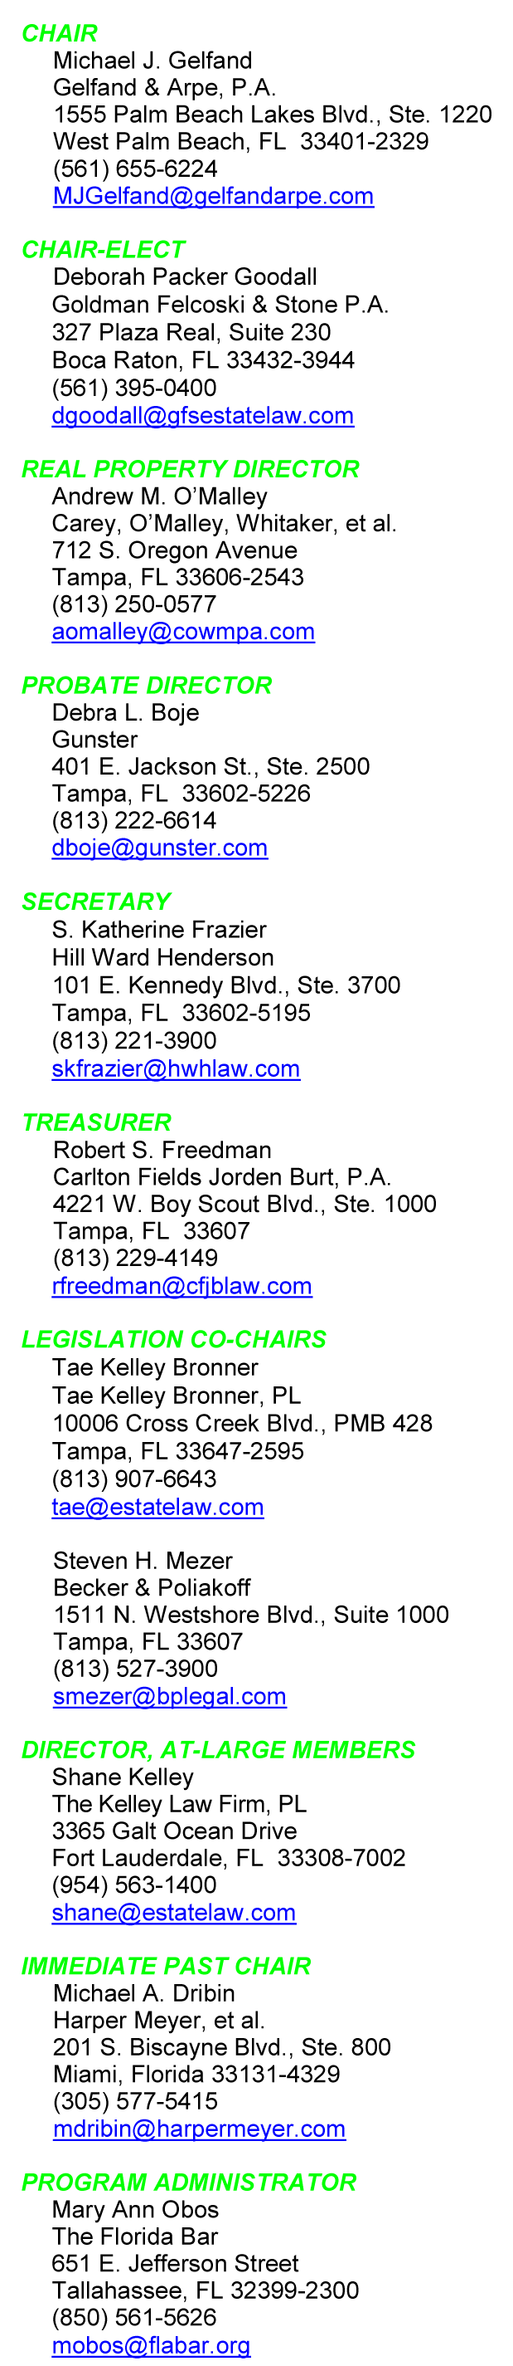
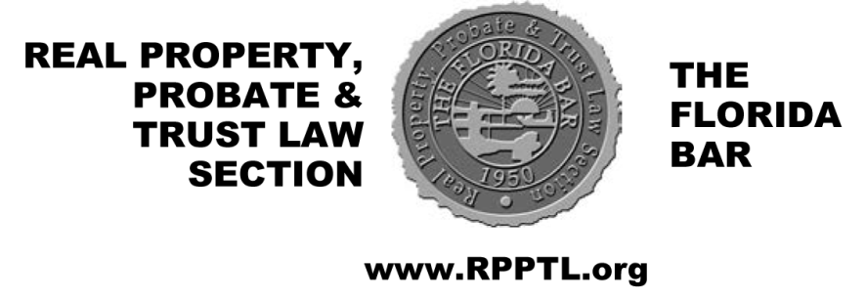
August 14, 2015

Dear Executive Council Members:

The Real Property, Probate and Trust Law Section convenes in Berlin, Germany, September 30 through October 3, 2015, for the Section’s Annual Out-of-State Executive Council Meeting. Berlin, Europe’s newest capital city, yet one of the oldest, is graced with magnificent museums, outstanding architecture, and delectable restaurants. Experience a different culture and reinforce ties with other members. As lawyers, jurists and counsel, gain a new perspective on our special role, safeguarding and balancing the rights of the individual and the community.

Berlin reveals the roots of events that shook the world for generations, and still haunts us today. Join us as we explore the highlights of 19th Century Imperial Prussia which anchored the cultural center of Europe, plumb the depths of the Nazi and Communist regimes, and discover the flowering of today’s Federal Republic as unified Germany returned its seat of government to Berlin. Compare and contrast architecture and art while partaking in the local food, wine and beer.

Our base, the Ritz-Carlton Berlin, literally straddles the line created by the Berlin Wall, overlooking a new city center replacing a no man’s land between opposing armies whose crossed swords were literally tipped with nuclear warheads. Just two blocks from the Tiergarten, Berlin’s Central Park, steps beyond are the capital buildings, the main shopping and entertainment district, and other locations of historical impact. Your walks will lead to discoveries at every turn.

Attached is a detailed registration form outlining our events. This letter provides further detail. Please complete the registration form, and return the form to The Florida Bar as indicated so that it is received no later than 4:00 p.m., August 28, 2015.

Berlin has so much happening that the Section’s events are focused. Consider following the lead of many of your fellow Section members and schedule to arrive a few days before or depart a few days after, or both! Our itinerary starts on the next page:
Wednesday, September 30, we motor coach to Sachsenhausen-Oranienburg. Imprisoning journalists and political prisoners, the first concentration camp was literally located in the middle of a town and surrounded by residences.

Following lunch on your own, stretch your legs, acclimate to the time zone and discover Mitte, the central city, on a short walking tour. Scheduled at your convenience, choose 2:00 p.m., 3:00 p.m., or 4:00 p.m. These tours start at the hotel entrance in Potsdamer Platz, a monument to the new city. Observing the new architecture we proceed by the Field of Stelae comprising the Memorial to the Murdered Jews of Europe, reminding you to make time to visit the information center under the Memorial. Stroll by the Tiergarten, the United States Embassy the Reichstag (German Parliament), through the Brandenburg Gate, down the historical Unter den Linden past the hulking Russian Embassy, through Friedrichstrasse, the main shopping street, to Checkpoint Charlie, the last outpost of the free world and scene of Cold War espionage and intrigue, before proceeding to the Gendarmenmarkt’s historical central Europe architecture.

After resting, but not sleeping, join your compatriots at a joyous and scrumptious welcome reception and dinner at the Ritz. Enjoy the opportunity to sample German cuisine. Afterwards we retire to the Fragrances club venue, our hospitality suite.

Thursday, October 1, tour geographically, outside the city center; and, tour historically, from the failed icons of Nazism to a celebration of democracy. Airport Tempelhof designed to showcase the Third Reich is contrasted with SA Prison Papestrasse (the first 36 registered will have an opportunity to tour inside the Prison). The longest city stretch of the Berlin Wall, renamed the “East Side Gallery” will be explained by one of its artists, a unique opportunity before the area is slated to be replaced by a condominium! Check out Checkpoint Charlie before sitting down at Meisterstück where we sample German favorites, including a flight of beers.

After lunch choose one of three tour options:

- Bauhaus. Tour the museum dedicated to the movement that changed 20th century western architecture, an experience available only in Berlin.

- Jewish Quarter. Walk the areas confiscated in the 1930’s, and observe their rebirth today, including a visit to the re-built and re-consecrated synagogue.

- Museum Island. Home to Central Europe’s most significant museums visit: Alte Nationalgalerie, Germany’s National Gallery; Neues Museum housing Germany’s collection of 20th-century art in a Mies van der Rohe structure, an icon to modernism; and, the Pergamon, named after the ancient Greek city, it displays the Pergamon altar, the market gate of Miletus, and other life-size monuments.

Thursday evening is yours to begin, or to continue, your exploration of Berlin’s restaurants, on your own, or better yet, with a group of members!

Friday, October 2, Executive Council members meet over a scrumptious German/American breakfast. Guests can register on a space available basis. Learn about salient legal issues of import to German and U.S. attorneys. Leading off, Irene Schmid, Michael Bedke’s partner at DLA Piper LLP, discusses issues created by confiscations of the Nazis and Communists, and unified Germany’s restitution and compensation process. She is followed by Florida’s own, the Honorable Rosemary Barkett, who we know as a former Justice of the Florida Supreme Court, retired Judge of the United States 11th Circuit Court of Appeals. Now a member of the International Tribunal for Iranian US claims, Judge Barkett speaks on American Lawyers Abroad: Working on International Tribunals, in International Arbitration, and in Global Efforts to Expand the Rule of Law.

Immediately following the meeting the three Thursday afternoon tours are repeated with an extra, everyone gathering for lunch at the Hackescher Hof located in the Mitte, just off of the Museum Island district. This is an excellent opportunity to refuel before concluding the afternoon on your own. Friday evening provides an opportunity to explore Berlin’s culinary gems as you plan with fellow members.

Saturday, October 3, off to Potsdam, and the last palace constructed for the last Emperor. Follow Truman, Churchill and Stalin’s footsteps where they redrew the boundaries of the postwar world at the “Potsdam Conference.” Crossing Sanssouci Park we enter the Neues Palais, constructed in the 1760’s, by King Friedrich II to mark the end of the Seven Years’ War and to impress the world with an exuberance of Baroque and Rococo style. At lunchtime we cross the street to lunch at the Restaurant Movenpick in Potsdam’s old historic mill.

Saturday evening we gather at the famed Gendamerie restaurant. In a former Bank constructed in the 1800’s, surrounded by modern art, we will dine on modern German cuisine. Thereafter, the more adventurous will engage in German nightlife.

Wrap-Up. Confirm your passport is in order, your airplane tickets are booked, and your suitcases are ready to go. I look forward to seeing you at the Ritz-Carlton Berlin. Please ensure that you turn in your registration forms with all information completed as soon as possible but no later than 4:00 p.m. Friday, August 28, 2015.

Sincerely,

Michael J. Gelfand
Chair

MJG/cm

P.S. The Section’s discounted Ritz-Carlton hotel block is sold out. If you made a reservation in the Section’s discounted hotel block, and you have to cancel, please do so through Dixey Teel (DTeel@flabar.org), so that another Section member on the wait list has the opportunity to use the discount. If you seek a room in the block, send an email to Dixey.

F:\WP\RPPTL\150812ctcouncilmembersmjg.doc

